**Mobile Testing with Robot Framework**

# Part 1: Installation

Note for JDK and Android Studio installation, can refer to <https://www.youtube.com/watch?v=W5hcHbzTjOc&list=PL4GZKvvcjS3vAPWLqWbKZogkL5cD71yrT&index=3>

## Install Java SE Development Kit (JDK)

1. Download Java SE Development Kit 8u202 from:   
   <https://www.oracle.com/java/technologies/javase/javase8-archive-downloads.html>. Where you want to download, website will ask you to login to Oracle or sign up if you don’t have Oracle account.
2. Run JDK installation file. Just follow instructions. You need to remember the folder location where JDK is installed.
3. After that, go to:  
   Start -> Setting (Gear icon above Power icon) -> System -> About (On left site and below) -> Advanced System Settings (as shown in figure below)  
     
   Graphical user interface, text, application

   Description automatically generated
4. Advanced System Settings window be opened. Click ‘Environment Variable …’  
     
   Graphical user interface, text, application, email

   Description automatically generated
5. Click ‘New’ under System Variable  
     
   Graphical user interface, text, application

   Description automatically generated
6. Write **JAVA_HOME** on ‘Variable name:’ and write location of JDK on ‘Variable value:’. Then click OK.  
     
   Graphical user interface, application

   Description automatically generated
7. Click ‘Path’

1. Click ‘New’ and write **%JAVA_HOME%\bin.** Then click Ok  
     
   Graphical user interface, text, application

   Description automatically generated with medium confidence
2. Don’t forget to click OK on Environment Variable window and then click OK on Advanced System Setting window.

## Android Studio

Note: Install Android Studio is recommended because it can install Android SDK (important for mobile testing) and install Android smartphone emulator.

1. Go to <https://developer.android.com/studio> to download
2. Run this installation and just follow the instructions and use Standard.
3. After finish installation, open Android Studio.
4. On front menu, click ‘Start a new Android Studio Project’
5. On creating menu, go to Minimum SDK and choose API 27: Android 8.1 (Oreo). Then click finish.  
     
   Graphical user interface, application

   Description automatically generated
6. After projected is created, click SDK Manager (top and right) as shown in figure below:  
     
   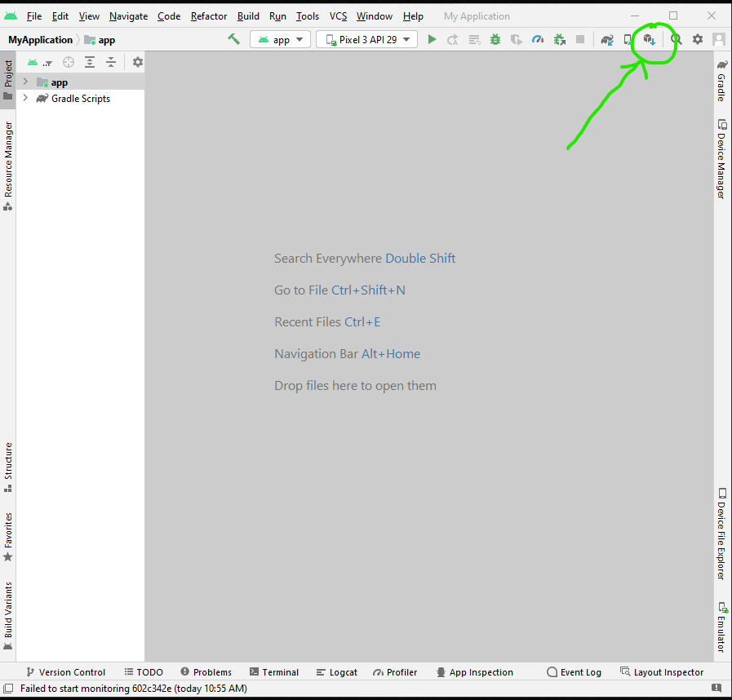
7. Go to Android SDK section (on left site). Go to SDK Tools and tick tools as shown in figure below.  
     
   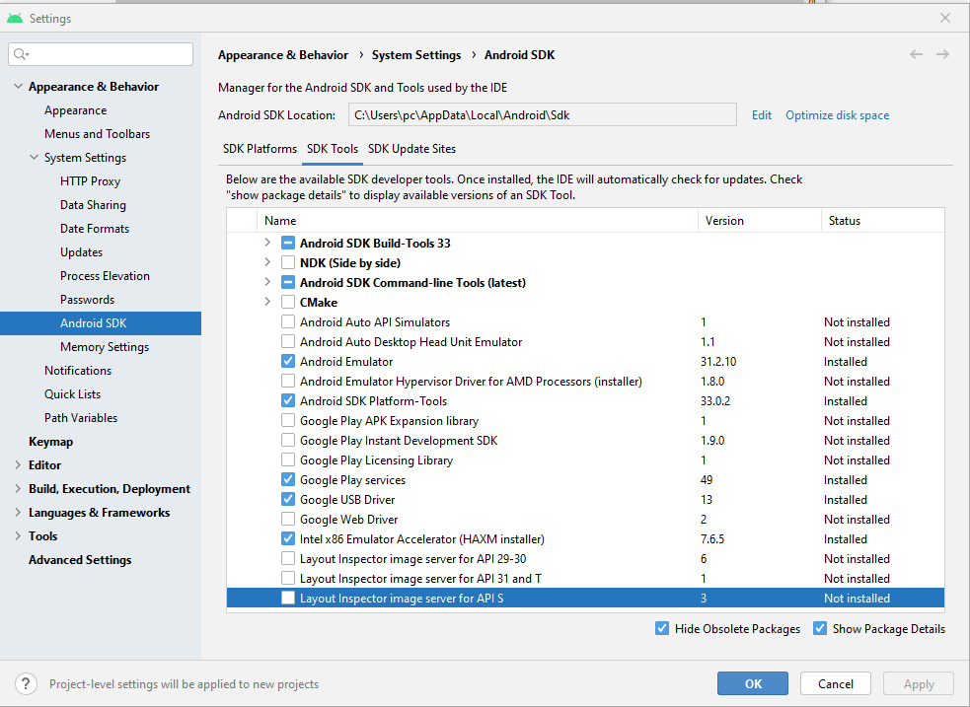
8. Then click OK. It will download and install tools that are no installed yet.
9. Take note Android SDK location as shown:   
     
   Graphical user interface, text, application

   Description automatically generated
10. Then open Advanced System Settings by following Step 3 and Step 4 from Java JDK Installation
11. Click ‘New’ under ‘User variable for pc’  
      
    Graphical user interface, text, application

    Description automatically generated
12. Write **ANDROID_HOME** on ‘Variable name:’ and write location of Android SK on ‘Variable value:’. Then click OK  
      
    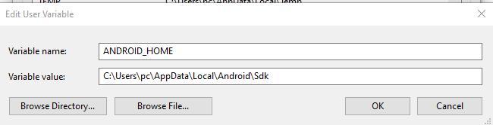
13. Then click Path under ‘User variable for pc’  
      
    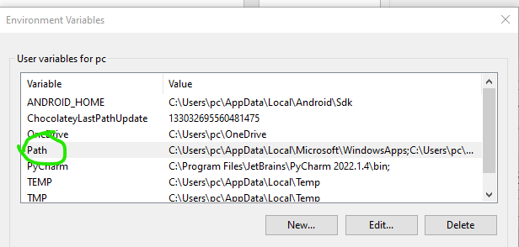
14. Just add variables as shown in figure below  
      
    Graphical user interface, text, application

    Description automatically generated
15. Don’t forget to click OK on Environment Variable window and then click OK on Advanced System Setting window.

## Python Installation

First, download python from [Download Python | Python.org](https://www.python.org/downloads/). Next, open python installation file. When it open, don’t click install yet. You need to tick ‘*Add Python 3.10 to PATH*’. Then, click ‘*Customize installation*’. After that, just click ‘Next’. Then, tick ‘Install for all users’ and click ‘Install’. Just wait it finish installation and then it is done.

To ensure that Python is already installed in computer, open command prompt and then just type ‘python -v’. It will show the version of Python.

## Node.js Installation

First, install node.js (<https://nodejs.org/en/download/> ). Please watch the instructions in the next

video, which explains how to download and install node.js using the Microsoft Installer (.msi).

<https://www.youtube.com/watch?v=AuCuHvgOeBY&t=2s>

## Appium Installation

Install Appium (<https://github.com/appium/appium-desktop/releases/tag/v1.22.3-4> ). Please watch the next video for instructions on installing Appium Desktop.

<https://www.youtube.com/watch?v=1ot8cZoUk6o>

## Vysor and ADB Driver

Next, you will need to set-up your mobile device to work with Vysor. Please watch the next video for instructions on how to install and use Vysor.

Download link: <https://www.vysor.io/>

Tutorial video link: <https://www.youtube.com/watch?v=ECZ5e-OuKqQ&t=1s>

For your phone to be viewable in Vysor, you will need to install ADB Drivers (Android SDK Platform) on your computer and enable USB Debugging on your phone.

Download link <https://adb.clockworkmod.com/>

Once you have installed Vysor and started it, you will see a screen like the image below. On this screen, you will see two links (highlighted in red, in the image) that will take you to a video showing how to enable USB Debugging and to the webpage where you can download the ADB Drivers Windows Installer, respectively.

Please note, in addition to the above, when enabling USB Debugging on your phone, and you are in the Developer Options on your mobile user interface (see image below), make sure you enable:

▪ USB debugging – Debug mode when USB is connected

▪ Install via USB – Allow installing apps via USB

▪ USB debugging (Security Setting) – Allow granting permissions and simulating input via USB Debugging

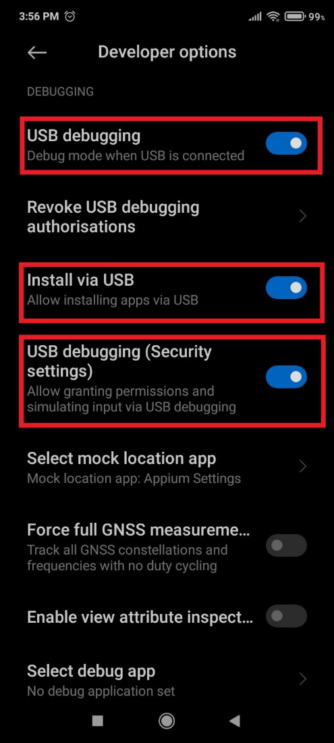

See this [link](https://www.embarcadero.com/starthere/xe5/mobdevsetup/android/en/enabling_usb_debugging_on_an_android_device.html) for additional information on this step: Enabling USB Debugging on an Android Device.

## Python Library Installation

1. Open command prompt and run it as administration
2. Type these two commands:  
     
   pip install robotframework  
     
   pip install --upgrade robotframework-appiumlibrary

## PyCharm (Python IDE) Download from <https://www.jetbrains.com/pycharm/download/#section=windows> and choose Community version